2017 | June Newsletter

B
right Horizons

Little Hands

News

Important Dates

June 1
^{st}

–

Kindergarten Prep Celebration

June 2
^{nd}

–

Kindergarten Graduation

June 5
^{th}

–

Summer Camp Begins

June 14
^{th}

–

16
^{th}

Hearing an
d Vision Screening

(
See page 2 for more information
)

June 16
^{th}

–

Irina’s Birthday

June 17
^{th}

–

Faculty Awards Banquet

June 18
^{th}

–

Kristen’s 10 Year Anniversary

June 18
^{th}

–

Anum’s Birthday

June 20
^{th}

–

Antra’s 10 Year Anniversary

June 20
^{th}

-

Jordan’s 5 Year A
nniversary

June 22
^{nd}

–

Erica’s 2 Year Anniversary

Thank You!

We would like to thank all the families that
made Teacher Appreciation so wonderful!

The teachers loved reading the special notes o
n
the website and especially enjoyed the
breakfast made by parents on
Tuesday, May 9
.

Thank you so m
r
uch for taking time out of you
busy schedules to make the teachers feel
special and appreciated!

Kindergarten Graduation

On June 2
nd

our Kindergarten class will be graduating! We
would like to take this opportunity to congratulate them on
a wonderful year filled with many successes.
Congratulations

to:

Alice Gilpin
,
Benjamin Brunet
,
Brayden Poholarz
,
Clare
O
’
Neill
,
Demetris Gjermano
,
Eli Metzger
,
Emma Washburn
,
Emmet Houdek
,
Heidi Deigl
,
Jonathon Georgakopoulos
,
Lucas Tain
,
Mayura Kidambi
,
Michael Swanson
,
Owen
Mueller
,
Stephen Gongola
,
Suzana Gros
man
,
Tyler
Stryko
w
ski

and
Willow Tharp

©

201

6
Bright Horizons Family Solutions LLC

Little Hands Child Development Center

2755
Sanders Rd. Northbrook, IL
60062

847
-
326
-
9500

|
littlehands3@allstate.com

Monday to Friday 6:30 am

–

6:30
pm

HEARING AND VISION SCREENING

In conjunction with The Child Vision and Hearing Test Act (Public Health Statute 410
ILCS205/)DCFS (The Department of Children and Family Services) requires vision and hearing screenings annually beginning at the age of 3 in all licensed daycare or preschool programs. In
order to fulfill this requirement and because we understand that good vision and hearing are vital to all stages of a young child’s development, Little Hands will provide a vision and hearing
screening by a private screener trained and certified by IDPH (Illinois Department of Health).
This year we will again be offering this service at no charge. Little Hands will cover the cost. We will screen all children in attendance on June 14, 15 & 16 that are over 3 years of age. Children aged 3 & 4 will receive both Vision and Hearing screenings. Children that will be entering
Kindergarten (at Little Hands or elsewhere) will only receive the Hearing Screening as they are required to have a full eye exam completed by an eye doctor for entry into Kindergarten.
If, for some reason, you do not want your child to be screened at Little Hands, please let us know. You will still be required to provide documentation that your child completed the vision
and hearing screening elsewhere within the last 12 months, so we strongly encourage you to take advantage of this convenient opportunity at no cost to you. For children over the age of 3, this is a mandatory requirement for your child’s file.
If your child is not going to be attending on their regularly scheduled days that week, please let us know so that we can have them tested on one of the other 2 days that testing will be occurring. For example, if you are planning to have your child out of the center on Thursday, June 15th, let us know so that we can test him/her on the 14th or the 16th.
Many vision or hearing problems that might otherwise go unnoticed can be discovered through the kind of simple screening that we will be doing at our center. If a screening test shows that
your child might have a problem seeing or hearing, you will be informed and asked to follow up
with an appropriate medical specialist for further testing. Vision screening is not a substitute for a complete eye and vision examination by an eye doctor. Your child is not required to undergo
the vision screening if an optometrist or ophthalmologist has completed and signed a report form indicating that an examination has been administered within the previous 12 months.
If you have any questions regarding the vision and hearing screening requirement, please do not hesitate to contact a member of the leadership team.

WELL AWARE WEEK

The week of May 22nd Little Hands highlighted Well Aware curriculum.
The older age groups had visits from Nurse Carla and pediatric dentists.
All of the children participated in healthy cooking and fitness activities.

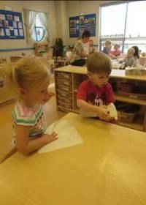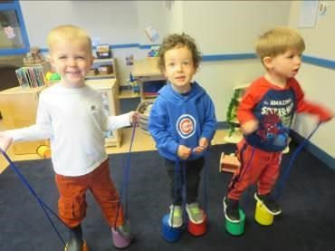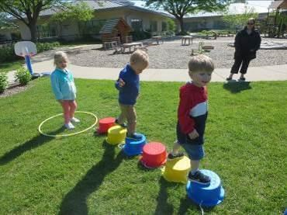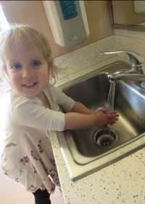

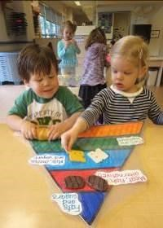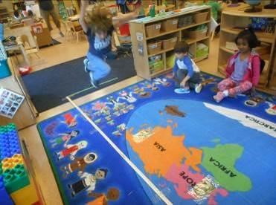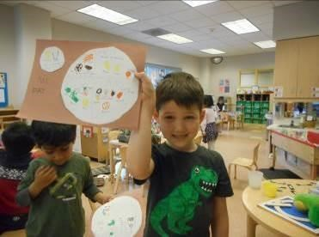

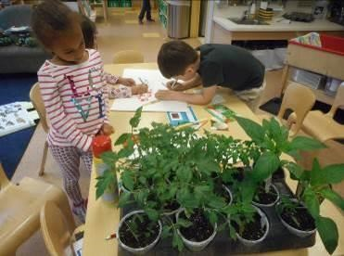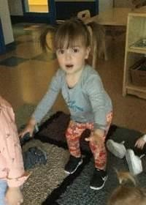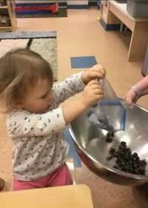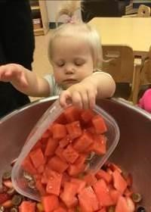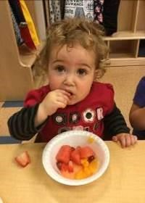

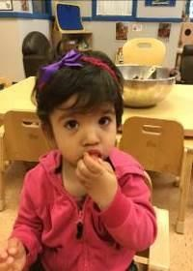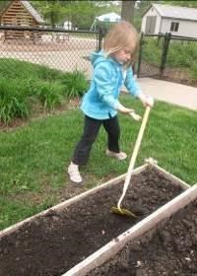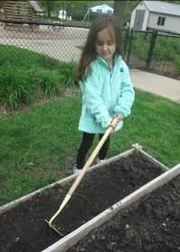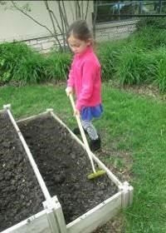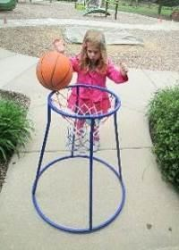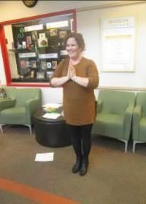

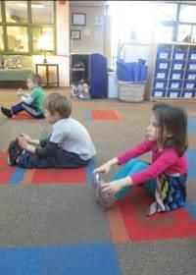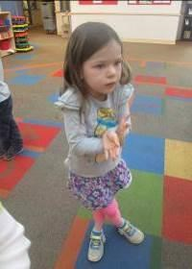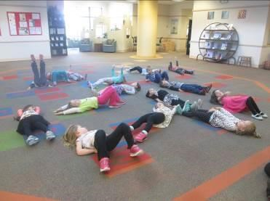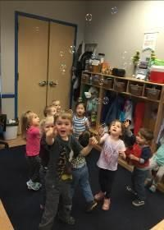

READY FOR SCHOOL NEWS

Phonemic Awareness: What Is It and Why Does It Matter?

Phonemic awareness is the understanding that words are made of phonemes (sounds). It is also the ability to identify and manipulate those sounds. Phonemic awareness is not phonics, but is a precursor to the ability to comprehend phonics instruction in the older years. Without phonemic awareness, phonics instruction makes little sense. In fact, strong phonemic awareness is a predictor of later reading success.
Parents have always intuitively nurtured their children’s phonemic awareness through nursery rhymes, songs, and word games. Below are a few ideas for taking this natural tendency even further through intentional phonemic awareness lessons. These lessons should be casual, brief, and fun. Always consider your child’s readiness when introducing them.

TODDLERS, TWOS, AND UP
- Read together. Share silly poetry, sing nursery rhymes, and read picture books with repetitive or rhyming verse. These activities help children understand the patterns and rhythm of language.
- Play listening games. Identify specific sounds, such as dogs barking, birds chirping, or a trash truck or ambulance driving by.

PRESCHOOLERS THROUGH KINDERGARTEN
- Continue reading a variety of literature to children, including nursery rhymes and repetitive stories.
- Play more advanced listening games. Hide a noisemaker, such as a ticking tock or a bell somewhere in the room. Ask your child to listen closely to find the location of the noise. Play two sounds, such as a bell and a bird call, one after the other. Ask your child to identify the first and the last sound.
Give two or three directions at a time, such as, “Roll the ball, jump once, and clap your hands.”
Building phonemic awareness doesn’t require worksheets or time-consuming instruction. Use these ideas when you’re in the car, waiting at the doctor’s office, or playing together. Keep a playful approach and stop before your child loses interest.
Many of the ideas on this page were adapted from www.sightwords.com. Please visit this site for more information and ideas. Visit Reading Rockets to watch a short video demonstrating simple word games parents and teachers can play with children. (http://www.readingrockets.org/reading-topics/phonemicawareness)

ARE YOU A #PROUDPARENT?

Throughout the month of June, Bright Horizons will be sharing
Share with us! stories of Proud Parents just like you on Facebook and Instagram.
Is your child graduating Kindergarten Prep this year? Did your baby take their few first steps? Did your toddler donate his toys to others? Does your preschooler’s endless imagination never cease to amaze you? What does your child do that makes you proud? Simply tag us at @BrightHorizons on Facebook or Instagram and use the hashtag #ProudParent and we’ll share your glowing moments of

parental pride.
My daughter rode a bike without training wheels today! #ProudParent @BrightHorizons

Trying to decide how and when to introduce your child to STEM subjects?

Click her
e

to watch a recording of our recent Family Matters W
ebinar,
A Parent's
Guide to STEM Education
, which explored how to help your child

learn STEM
at every age and stage.

