 | MONDAY | TUESDAY | WEDNESDAY | THURSDAY | FRIDAY
November 2nd- November 6th | Chicken Nuggets  Cooked Carrots  Dinner Roll  Fruit | Toasted Cheese  Baked Beans  Fruit | Chicken Fajita  Mixed Vegetables Dinner Roll  Applesauce | Salisbury Steak  Mashed Potatoes  Dinner Roll  Fruit | Whole Grain Personal Pizza  Steamed Broccoli  Whole Fruit Frozen Fruit
November 9th-November 13th | Deli Sandwich  Green Beans  Fruit | Macaroni & Cheese  Baked Beans  Fruit | Toasted Cheese  Sweet Potato  Applesauce | Hamburger  Whole Grain Bun  Sweet Yellow Corn  Fruit | Pizza Calzone  Steamed Broccoli  Applesauce Cup
November 16th- November 20th | Chicken Strips  Green Beans  Dinner Roll  Fruit | Cheeseburger  Baked Beans  Dinner Roll  Fruit | Spaghetti with Meat  Sauce and  Dinner Roll  Applesauce Cup  Steamed Carrots | Cheesesteak  Whole Grain Bun Green Peas  Fruit | Burger  Steamed Broccoli  Applesauce Cup
November 23rd-November 27th | Chicken Sandwich  Whole Grain Bun  Potato Rounds  Fruit | Cheeseburger  Baked Beans  Dinner Roll  Fruit | Chicken & Gravy Mashed Potatoes  Mixed Vegetables  Fruit | Center Closed | Center Closed
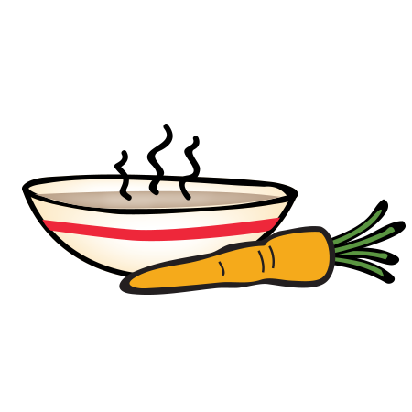
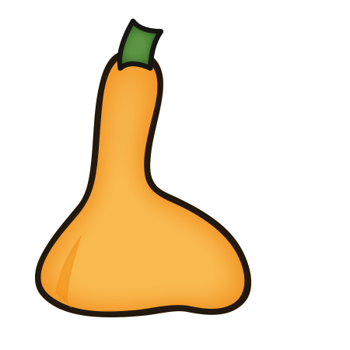
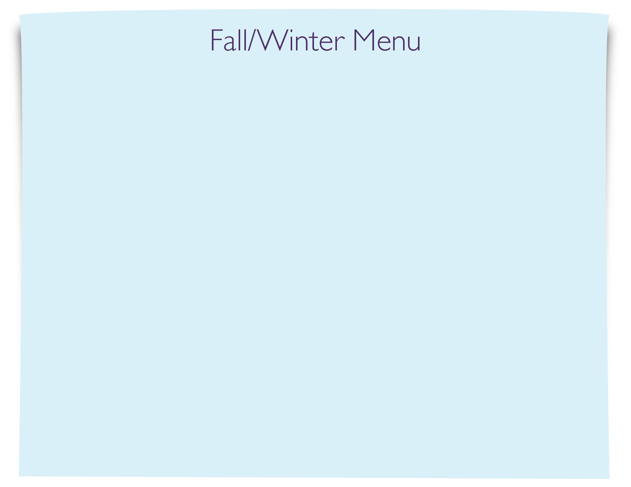
November Lunch

