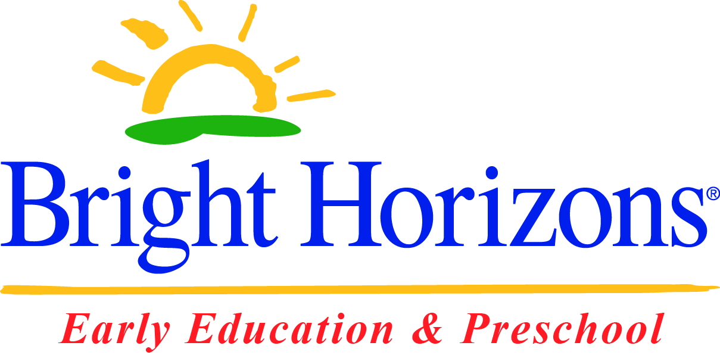

**Bright Horizons at Rockaway**

is hosting an

Open House Week

September 29, 2014 to October 3, 2014

9:00 a.m. – 5:00 p.m.

See our [*The World at Their Fingertips*](https://www.brighthorizons.com/programs/care-school-curriculum) curriculum in action.

Visit our well-appointed classrooms.

Meet our talented [educators](http://www.brighthorizons.com/little-inspirations/).

Experience all the [Family Resources](http://www.brighthorizons.com/family-resources) we offer.

Immerse yourself in quality early childhood education.

*Attend our Fall Open House and register by October 31, 2014*

*to receive $150 Tuition Credit!*

**Bright Horizons at Rockaway**

295 Route 46 West

Rockaway, NJ 07866

973-586-7775

rockaway@brighthorizons.com

www.brighthorizons.com/rockaway

***FALL OPEN HOUSE WEEK***