2016 | April Newsletter

The Child Development Center for Bristol-Myers Squibb Lawrenceville

**From the Director**

Welcome Spring!

As we look forward, April will be filled with many special events, as well as showing our appreciation for the children, teachers, and families within the Center. (Parents- Be on the lookout for some fun surprises!)

Nurse Jeanne will be providing a CPR/First Aid Workshop for Families on Tuesday, April 26th. Please sign up at the front desk if you are interested in attending this informative session.

Parent’s Night Out will be on Friday, April 29th! Your child(ren) will enjoy pizza, games and a movie while you spend a child-free night shopping or enjoying a nice dinner!

Throughout the Week of the Young Child, the children will participate in many fun-filled themes and activities, with a couple of special visitors, as well.

The Garden Café will open on Monday, April 18th through Friday, April 29th. Families are welcome to sign up and enjoy a special lunch with their child during this time.

Thank you!

Important Dates

4/4 – STEM Lab opens, pajama party

4/5 – Parent Partnership Meeting 12:15

4/6 – Lovey Williams Concert

4/11 – 4/15 – Faculty Appreciation Week

4/18 – 4/29 – Garden Café Open

4/22 – Earth Day, GardenWorks Parent Event

4/26 – Friends and Family CPR Info Session

4/29 – Parent’s Night Out

Reasons to Celebrate

4/1 – Happy Birthday Laura Grabowski!

4/2 – Happy 9th Anniversary to Jessica Aquaro and Penny Stout!

4/3 – Happy Birthday Laurie Davis!

4/15 – Happy 3rd Anniversary Jordyn Gennello!

4/16 – Happpy Birthday Andrea Hines

4/26 – Happy Birthday April Anderson and Happy 6th Anniversay Sara Sowards!

****The CDC for BMS Lawrenceville****

Rte. 206 & Province Line Rd.

609-252-6200 | [cynthia.guler@bms.com](mailto:cynthia.guler@bms.com)

M-F 7:00am – 6:30pm

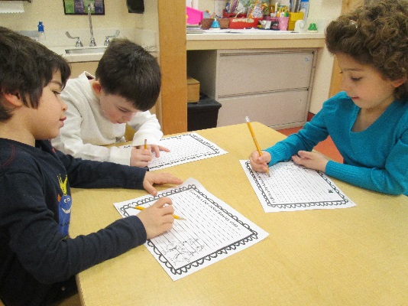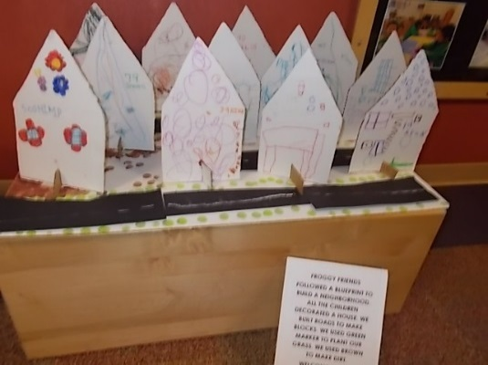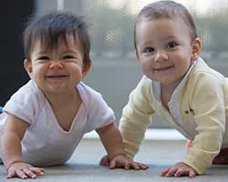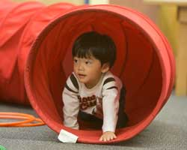

Infant

Our Infants have been learning many Language Works skills over the past month! We have been concentrating on new sounds, rhyming, and using expressive language. We kicked off the month with Dr. Suess’s birthday and the children enjoyed reading such classics as Hop on Pop, One Fish Two Fish, and many others! Over the next month we will be working on expanding our Science Rocks skills through our GardenWorks program. Exploring the outdoors is such a wonderful way for the little ones to learn about life!

Toddler

Our Toddlers had a terrific month celebrating Language and Literacy! They also started concentrating on Science Rocks in preparation for our STEM lab opening in April. Activities such as pouring water through PVC pipes or examining density based on sugar water are age appropriate, fun ways to learn about science! Many classrooms are already working on their GardenWorks projects and planting grass and vegetable seeds! We can’t wait to watch them grow!

Preschool

The Butterfly Buddies learned all about ROYGBIV this month as they focused on the rainbow! Each day they explored a different color and did activities with that color in mind. Check out the great rainbow that they created in the classroom. Also, a special thanks to MaryKate Burd, Aedan’s mom, for coming in to read The Littlest Leprechaun and share delicious Irish soda bread with us!, The Froggy Friends were very busy developing blueprints, learning new vocabulary words and exploring trucks and tools during their construction unit. They incorporated STEM by adding inclines to their designs. They also made their own class neighborhood, complete with detailed houses and roads. As the first day of Spring arrived, the Dragonlfies couldn’t wait to get started with our Gardenworks program! They tried a neat spond and seed planting project and, of course, dug for worms! They also sorted seeds in our Math Counts center.

Kindergarten

The Hummingbirds are officially authors and illustrators! They spent the whole literacy month writing and illustrating classroom books. They really enjoyed exploring rhyming words during the Dr. Seuss unit. The Hummingbirds also made three dimensional shapes using various materials. Great job, Hummingbirds! Other areas that were explored this month included: adjectives, word families, lowercase letters, guided reading, patterns, teen numbers, dividing in half, graphing, counting by 2’s, money, adding and subtracting, magnets, building towers, and diversity.

CLASSROOM HIGHLIGHTS

Where in the World? Geography in the Early Childhood Classroom

In the July, 2015 issue of [*Young Children*](https://issuu.com/naeyc/docs/yc0715_brillante?e=2112065/13914599)*,* Pamela Brillante and Sue Mankiw discuss the value of fostering a sense of place in young children, of helping them develop deep roots and a sense of belonging to their community and environment. This sense of place gives children the tools they need to later “protect natural and cultural resources, reduce violent conflicts, and improve the quality of life worldwide.”

In short, the purposes of studying geography in early childhood are:

* To help children understand and appreciate their local community.
* To foster a sense of wonder and curiosity.
* To increase children’s knowledge of the world as a vast space with varied peoples and cultures.

When we think of geography, we tend to think of maps and globes or geographic regions. For young children, though, geography should include a study of both physical geography – maps, regions, land features, and climates – and human geography – the study of how humans interact with each other and the world.

Viewed through this lens, geography isn’t a subject taught in isolation. Geography happens every day as you read, cook, sing, learn, and explore with your child. Below are a few ideas for studying geography with your young child:

* Work to create a “sense of place” in your home. Display photos, artwork, and mementos that reflect your family’s interests and values. What defines your family culture? Perhaps it’s the library of books that speaks to your love of learning or the game cupboard or sports equipment that reflects your family’s hobbies.
* Explore both the natural and human geography near your home. Walk through leaves in the fall, visit a nearby pond, or turn over rocks to find bugs. These simple activities create a sense of deep security for children and encourage a lifelong love of nature. Get to know the people who live and work in your community. When you visit a nearby bakery, hardware store, coffee shop, or post office, talk with the people who are helping you. These relationships help ground people within their community.
* Display maps and globes in your home. Point out places that you’ve visited or lived. Share photos and mementos from those places. Create books that depict stories of your trips or special events.

The study of geography, like most learning, enriches our understanding of ourselves and our world. In [“Pedagogy of Ecology,”](http://www.rethinkingschools.org/restrict.asp?path=archive/23_04/peda234.shtml) Ann Pelo described her return to her childhood home: “I remembered with a child’s open-hearted joy how it feels to give yourself over to a place, to be swept into an intimate embrace with the earth. I understood that place shapes our identity.” Children lucky enough to experience this deep connection become securely-grounded adults who can extend that deep respect for place to all cultures and regions of the earth.

Ready for school News

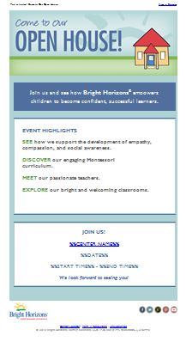

**It’s Open House Month!**

Throughout April, Bright Horizons’ around the country will be holding Open House Weeks for families to learn more about our programs and how we educate children to become successful lifelong learners.

If you have a friend or family member that might be interested in joining, we would be happy to provide information for you to share with them!

Check in with your center director for exact dates and times.

COMING SOON: Teacher and Staff Appreciation Month

Each year we take the month of May to celebrate and recognize staff whose hard work and dedication help us accomplish great things and make Bright Horizons a wonderful place for children and families.

May is almost here! Make sure to mark your calendars. ☺



*Earth Day is April 22nd!*

We encourage you to celebrate the holiday by making one pledge or one change to be more environmentally conscious this year. Small changes can lead to a big impact!

Interested in learning about how you can celebrate Earth Day with your child(ren)? Check out our  
[Earth Day Activities for Families](http://www.brighthorizons.com/family-resources/e-family-news/2012-earth-day-activities-for-families/).

CONNECT WITH BRIGHT HORIZONS



Bright Horizons News