Reasons to Celebrate

February 4 – Happy Birthday Jessica Ehrmann!

February 5 – Happy Birthday Tara Dietrich!

February 7 – Happy Birthday Donna Morrisette!

February 8 – Happy 17th Anniversary Tara Dietrich, Penny Stout and Cyndi Guler!

February 12 – Happy 15th Anniversary Irma Morataya!

February 16 – Happy 17th Anniversary Ying Zheng!

February 17 – Happy Birthday Nick Cheng!

February 19th – Happy 3rd Anniversary Laura Grabowski!

**From the Director**

Many important events will be held this month:

We invite you to the Preschool Preview on Tuesday, February 9th at 4:30pm. During this event, families will have the opportunity to explore their child’s next classroom and visit with the teachers; learn more about the curriculum, *The World at Their Fingertips*; and engage in activities with their child that highlight STEM (science, technology, engineering, and math) learning in the classroom.

The Kindergarten Open House will be on Tuesday, February 16th at 4:00pm. Children who will turn five years old by December 31, 2016 are eligible for this program.

Camp Explorations: X-treme Summer Fun is available to children between the ages of six through twelve. Please note that children must be 6 years old by June 1, 2016 or have completed a community-based kindergarten in order to be accepted into the program. Join us on Tuesday, February 23rd at 4:00pm for more information about the exciting events planned this summer.

Families are also welcome to attend the Lovey Williams’s concert on Friday, February 12th!

Important Dates

February 2 – Parent Partnership Meeting 12:15

February 4, 11, 18 – Music for Infants and Toddlers

February 3, 10, 17, 24 – Justin Jr. Sports

February 9 – Preschool Preview 4:30pm

February 12 – Sweetheart Concert 10am

February 15 – Center Closed: President’s Day

February 16 – Kindergarten Open House 4pm

February 23 – Camp Open House 4pm

The Child Development Center for Bristol Myers Squibb Lawrenceville

2016 | February Newsletter

****Bright Horizons at <Center Name>****

Address, City, State, Zip

Phone | [Email](mailto:seneca@brighthorizons.com)

Days & Hours

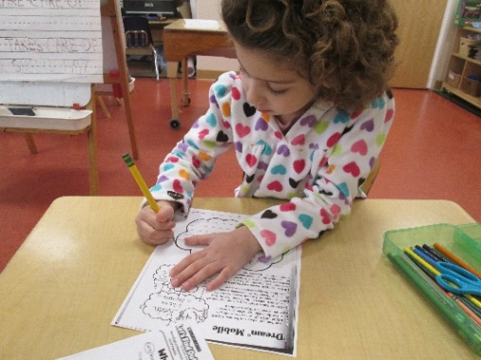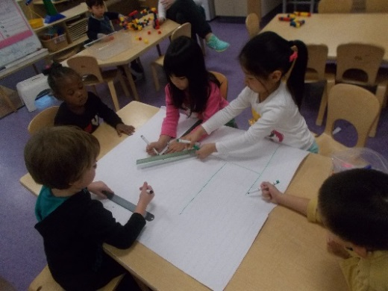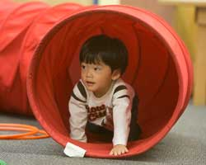

Infant

The Infants have been working on coordinating body movements and identifying different body parts by playing games and singing songs such as Head, Shoulders, Knees and Toes. We have been working on following simple one step directions as we practice walking in the hallway together and climbing over the climber in the Movement Matters Zone. Our younger infants are also beginning to learn about Object Permanence as we play peek- a- boo with colored scarves!

Toddler

Our Toddler classrooms are inviting families to share their cultures and traditions with us! Whether it is a special story, an art project, or a piece of décor- we would love to incorporate it into our lesson plans and daily classroom life! The rooms are also in the process of incorporating many more natural elements into the classroom, such as bamboo texture boards and wicker baskets. We have been having a wonderful time enjoying the snow outdoors and experimenting with Science Rocks concepts such as melting as we play!

Preschool

The Frogs kicked off the year by learning about primary and secondary colors. They even explored colors through movement items such as color mats, scarves and ribbons. The Dragonflies enjoyed taking a closer look at modes of transportation. Patterning with the vehicles was a great way to support their emerging mathematical skills. The Butterflies classroom discovered things that go and wheels this month. They made cardboard ramps and tunnels, made predictions about shapes that would roll and played with gears. Speaking of wheels, please join us for the Preschool Preview on Tuesday, February 9th to see what wheel inspired projects and activities all three Preschool classrooms have been working on.

Kindergarten

The Hummingbirds read several books and their Let’s Find Out magazine to learn about Dr. Martin Luther King Jr. The children made an “I have a Dream” mobile, where they used inventive spelling to describe their dreams for themselves, their community and the country. Kindergarten also focused on word families, comprehension, descriptive words, final sounds, cooperation, shapes, number stories, symmetry, patterns, state of matter, sight words, and the HWT Center Starters (Q, G, C, O) If your child will be 5 years old by December 31, 2016, please join us for the Kindergarten Open House on Tuesday, February 16th.

CLASSROOM HIGHLIGHTS



Ready for school News

Language Development in the Early Years

Language development is one of the truly remarkable aspects of human growth. From earliest infancy, human babies strive to communicate with others. By age three, most children speak between [250 and 500 words](http://www.mayoclinic.org/healthy-lifestyle/infant-and-toddler-health/expert-answers/toddler-speech-development/faq-20057847), using pronouns correctly in 3 to 4 word sentences. This explosion of language is an innate developmental ability; however parents can foster language growth through intentional language use. Below you’ll find tips to build your child’s early speech.

* Respond to your baby’s early attempts at communication. Even in the first few weeks of life, your baby communicates through cries, eye contact, gestures, and facial expressions. These early communications build trust and help ensure your baby’s well-being. Responding promptly to your child teaches her that communication works – and encourages more of it.
* Teach your baby sign language. You and your baby don’t need to become fluent in ASL, but a few simple signs can reduce frustration for both of you while your baby gains verbal language. Teach basic signs for common words like more, drink, cup, snack, and play. You might worry that teaching sign language will delay speech, but a study published in [*The Journal of Applied Behavior Analysis*](http://www.ncbi.nlm.nih.gov/pmc/articles/PMC1868823/)found that using sign language can actually encourage speech.
* Talk, talk, and talk some more. A [2013 study](http://news.stanford.edu/news/2013/october/fernald-vocab-development-101513.html) from Stanford University found that toddlers whose parents talked frequently and directly to them had significantly larger vocabularies and more highly-developed language skills. Hearing language second-hand or on television did not produce the same results. Talk with your child throughout the day. Describe where you’re going or what you’re making for dinner. Sing songs and nursery rhymes, read books, and play simple games.

Parents often wonder what to expect in terms of [language development.](http://www.asha.org/public/speech/development/chart/) During the first year, your baby will gesture, babble and make eye contact to communicate. Most babies say their first words around their first birthday. During the second year, toddlers gain new words every week. They understand far more than they can say. They begin to put two or three words together in sentences and ask simple questions. By age three, most children have a word for almost everything. They can follow one or two step directions. Most importantly, they’re interested in listening and communicating with those around them.

Keep in mind that every child develops at his or her own pace. Some children have precocious vocabularies while others develop language more slowly. Talk with your pediatrician if you have concerns. In the meantime, keep talking.

Bright Horizons News

**Quick tips to make your life as a parent easier**

#BH5MinFix is a new weekly series where you can get 5-minute solutions to the parenting struggles that are oh-so-common when raising children. Some topics we discussed recently include the things we’re vowing not to stress about this year and simple ways to make school lunches your little ones will eat and enjoy.

**Get some ideas and share your own with us!**

We invite you to join the discussion on our social pages [Facebook](http://campaigns.brighthorizons.com/pnfb), [Instagram](http://campaigns.brighthorizons.com/pnig), and [Twitter](http://campaigns.brighthorizons.com/pntw). Every Monday we announce the topic for the week; chime in with your best solution to the topic anytime Monday-Friday. Then check the [Family Room](http://campaigns.brighthorizons.com/pnfrb) blog on Saturday for a round-up of the top tried-and-true solutions we heard that week!

**2016 Family Matters Webinar Schedule**

We are excited to share the 2016 Family Matters webinar schedule! Join us as we discuss parenting skills and offer guidance, tips, and resources to help your families navigate the many stages of childhood development and beyond. Download the [calendar](https://mybrightweb.brighthorizons.com/dept/parentmkt/Parent%20Webinars/2016%20Family%20Matters%20Webinar%20Series%20Event%20Schedule.pdf) and feel free to share with other parents!

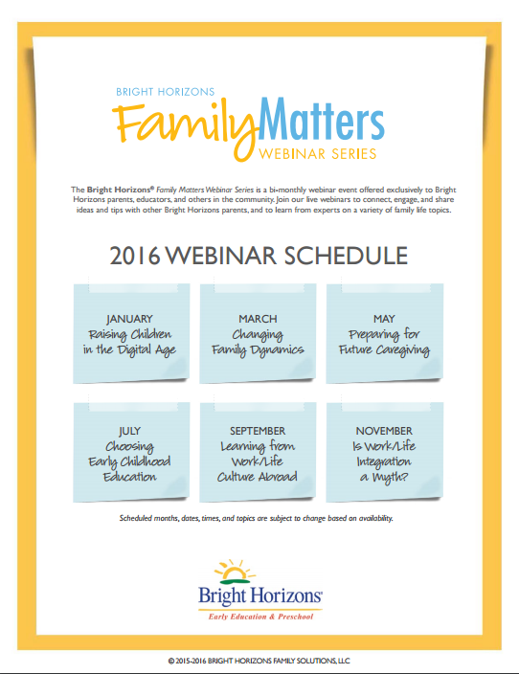



CONNECT WITH BRIGHT HORIZONS

