**From the Director**

Turn the nightly news on and you’re inundated with seemingly unsolvable problems. The issues of poverty, war, disease, homelessness, and crime loom large. It’s unlikely that we’ll ever solve all the world’s problems, yet small acts of kindness can make a difference in individual lives. Children, with their goodness, innocence, and hope, can be active participants. Here are a few suggestions on encouraging volunteerism in your family.

* Start small. Host a bake sale, gather school supplies, or work at a food bank. As you and your children gain experience, you can organize larger events.
* Talk with your children about world events at a level that is age-appropriate for them. Don’t inundate children with more information than they can handle, but help them understand that others need compassion.
* Choose projects that complement your family’s interests and values. For example, a young soccer player gathered more than 1,200 soccer balls for children in Africa.
* Piggyback your efforts with those of local schools, child care centers, and nonprofit organizations.

2016 | September Newsletter

The Child Development Center for Bristol Myers Squibb Lawrenceville

Important Dates

September 5th – Center Closed

September 6th – First Day of Kindergarten

September 7th - Parent Partnership Meeting 12:15pm

September 20th – Curriculum Night 5-6pm

September 29th – Picky Eaters Parent Workshop 4pm

Reasons to Celebrate

9/7 – Happy 12th Anniversary Donna Morrisette!

9/10 - Happy 8th Anniversary Rosa DiMeglio!

9/17 – Happy 1st Anniversary Andrea Hines!

9/22 – Happy 8th Anniversary Cheryl Raywood!

9/28 – Happy 1st Anniversary April Anderson!

****The Child Development Center for Bristol Myers Squibb Lawrenceville****

Rte. 206 & Province Line Rd., 08540

609-252-6200 | [cynthia.guler@bms.com](mailto:cynthia.guler@bms.com)

Days & Hours

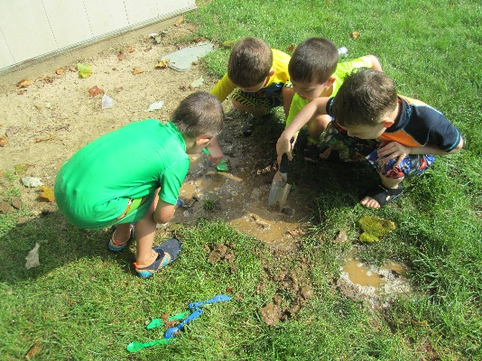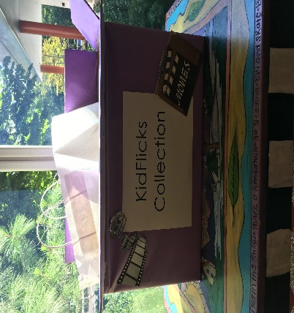

Infant

Our Infants have been working on Movement Matters activities over the month of August! They are continuing their Infant Signature Practices and incorporating books about movement in their daily reading. We are looking forward to September and our Curriculum Night to showcase our program! Hope you will join us on September 20th at 5 p.m.!

Toddler

Our Dinosaur Common Area was a big hit! As the Olympics became a common household word, the children started races, ring tosses, “kayaking” in the boats, and even a podium for 1st place! Over the next month we will be concentrating on our Well Aware aspect of the curriculum and learning about all types of healthy foods!

Preschool

Throughout August, the Preschool and Kindergarten children explored a variety of fun themes and welcomed a few visitors! They participated in the Olympics during our Fun and Fitness week, created fossils while we learned about Dinosaurs in Mad Science and enjoyed a special Wet and Wild water play day! The most influential theme that we learned about was our Dare to Care week. Families donated gently used movies that will be distributed to pediatric hospitals for their movie libraries, did good deeds at school and at home and shared them on our Giving Tree, created placemats for Meals on Wheels and completed coloring pages that will be sent to Color-A- Smile (a non-profit organization that spreads smiles with cheerful drawings. These acts of kindness are a great representation of our Growing Givers program, which offers ideas for how to promote empathy and social awareness through daily interactions and through service opportunities at home or out in the community.

Kindergarten

In addition to the activities and projects listed above, our Kindergarteners have been busy becoming familiar with routines and work stations throughout the classrooms. They have been focusing on beginning sounds, counting, letters, numbers, helping others teamwork and more! One of our absolute favorite activities in August…a special MUD PLAY day! We look forward to welcoming two new friends and officially starting the school year on Tuesday, September 6th!

CLASSROOM HIGHLIGHTS



Ready for school News

Communicating with Teachers

Late summer and fall is often a time of transition for families as children begin new schools, change classrooms, or simply embark on new learning experiences within the same classroom. This is a time for parents and teachers alike to take inventory, set goals, and begin anew.

Don’t forget parent-teacher communication in your back-to-school plans. Developing strong relationships and effective communication strategies with teachers is one of the most important things you can do to ensure a positive learning experience for your child. In this parent newsletter, we offer tips for successful communication with your child’s teacher:

* **Build relationships.** Sooner or later, you may have a question or concern. Bringing up a concern is so much easier if you already have a strong relationship with your child’s teacher. Touch base with your child’s teacher each day, even if it’s just saying hello, thank you, or goodbye in the evening. Express appreciation for the teacher’s efforts. Share helpful information about your family and occasionally ask the teacher about herself, e.g., “How was your weekend?”
* **Establish preferred methods of communication**. Be sure to read all center correspondence, newsletters, and daily reports so you’re in the loop. Remember that a teacher’s primary focus is the well-being of the children. Morning arrivals and afternoon departures are often busy. Keep communication during these times brief; set a time outside of drop-off and pick-up to talk further. Understand that teachers can’t always respond immediately when they’re with children.
* **Offer to help.** Teachers know how busy parents are and don’t expect hours of volunteer time. They do appreciate small gestures, though, based on your availability, strengths, and interests. Offer to read a story to the children occasionally or donate a few recycled art supplies. Ask your child’s teacher for ideas.
* **Discuss concerns directly with the teacher.** Build respect and trust by addressing any concerns confidentially with the teacher. Use tact and consider the teacher’s perspective. Take a collaborative approach and work together to find solutions. Be sure to develop an action plan and follow up. Seek a director’s guidance if you need additional help.
* **Remember that teachers are human.** Teachers work hard to create peaceful, engaging environments for children, but the early childhood classroom can be unpredictable and challenging. If your child’s normally cheerful teacher seems busier than usual or unable to talk, chock it up to an especially “adventurous” day of teaching.

Your child’s teacher can be one of your most powerful allies, supporting you and your child through challenges and cheering for your successes. The time you spend cultivating that relationship will benefit both you and your child.





****Celebrating 30 Years of Learning!****

Bright Horizons is proud to celebrate 30 years as the early educator and partner of choice for families and employers around the world. We look forward to supporting the next generation of parents and children, and continue to cheer the big steps made by the early learners at all of our centers. Because the most exciting milestones are the ones we get to celebrate with parents and children every day. ​

**Curriculum Night 2016**

Join us for our Curriculum Night event, where families from all age groups will have the opportunity to experience a *day in the life* of their child and learn about the upcoming year with **Bright Horizons**®.

During the event you and your family will have the opportunity to:

* **Meet** your child’s teachers
* **Explore** the Bright Horizons partnership
* **Learn** about ***The World at Their Fingertips***® curriculum for your child’s  
  age group
* **Discover** how our emergent curriculum approach will use your child’s own interests to inspire those next big steps

Share in your Bright Horizons experience and invite your friends and family to join you at Curriculum Night. Please see our Center Director or your child’s teacher if you have questions or would like more information about Curriculum Night. We will see you there!

CONNECT WITH BRIGHT HORIZONS



Bright Horizons News