___: Egg Allergen
___: Dairy Allergen
___: Fish Allergen
___: New Item

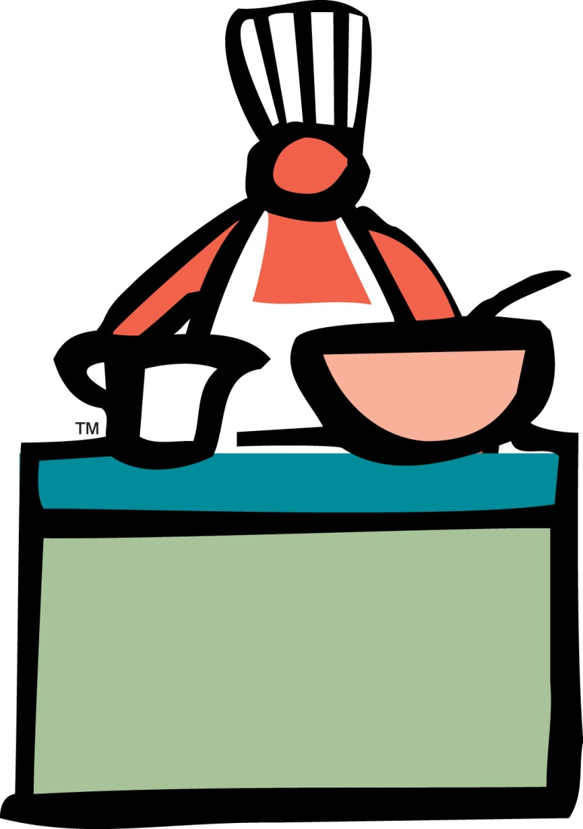 Little Hands Spring Menu Week 1

Monday | Tuesday | Wednesday | Thursday | Friday
Whole Wheat Toast w/ jelly  Turkey Sausage  100% OJ  Milk  Veg. Sub: Vegetarian Sausage | Scrambled Eggs  Biscuit  Apple Sauce  Milk  Dairy Sub: Wheat toast  Egg Sub: WW English Muffin and Cream Cheese | Hot Oatmeal  Fresh Bananas  Milk | Southwestern Egg Flatbread  Fresh Oranges  Milk  Egg Sub: Cheese & Bean Flatbread  Dairy Sub: Egg & Bean flatbread  Inf/Tod sub: Mandarin Oranges | Whole Wheat Blueberry Pancakes w/ Syrup  Peaches canned in water  Milk  Egg Sub - WW English Muffin with Jam
Turkey Meatballs with Wheat Spaghetti & Marinara  Green Beans  Fresh Apples  Whole Wheat roll  Milk  Veg sub: Veg Meatballs & Wheat Penne w/ Marinara  Inf/Tod Sub: Applesauce | Roast Beef & Cheese on Wheat  Fresh Fruit Salad  American Bounty Veg Soup  Milk  Veg Sub: Cheese Sandwich on Wheat  Dairy Sub: No cheese | Sweet and Sour Chicken  Steamed Mixed Veggies  Fresh Oranges  Fluffy Rice  Milk  Veg Sub – Sweet and Sour Tofu  Inf/Tod Sub: Mandarin Oranges | Chicken & Broccoli Casserole  Fresh Fruit salad  Milk  Veg Sub -Macaroni and Cheese (whole wheat pasta) + Steamed Broccoli  Dairy Sub- Baked Chicken Breast, Rice, Broccoli | Margherita Whole Wheat Pizza  Fresh Steamed Green Beans  Fresh Cantaloupe  Milk  Dairy Sub: Bagel Pizza with dairy-free shredded cheese
Low fat Yogurt  Graham Crackers  Water  Dairy Sub: Dairy-Free Cheese | Whole wheat English Muffin  Jelly  String Cheese  Water  Dairy Sub: Dairy-Free Cheese | Fresh Carrot sticks  Ranch Dressing  Whole grain crackers*  Water  Inf sub-Diced steamed zucchini  Dairy Sub: Italian dressing | Cheddar Cheese  Whole grain crackers*  Watermelon  Water  Dairy Sub: Hummus* | Peach Muffin Square  Water  Egg/ Dairy Sub – fresh fruit
Apr 17, May 15, Jun12 Apr 18, May 16, Jun 13 Apr 19, May 17, Jun 14 Apr 20, May 18, Jun 15 Apr 21, May 19, Jun 16
Week 1: Milk is rbgh free
We do not provide cow’s milk to infants younger than 12 months. Toddlers and Twos receive Whole Milk. Preschool, KP and Kindergarten receive 2% Milk
We do not offer solid foods or fruit juices to infants younger than 6 months
___: Egg Allergen
___: Dairy Allergen
___: Fish Allergen
___: New Item

Little Hands Spring Menu Week 2

Monday | Tuesday | Wednesday | Thursday | Friday
Cheerios  Turkey Sausage  Fresh Bananas  100% OJ  Milk  Veg Sub- Vegetarian Sausage | French Toast Sticks with Syrup  Applesauce  Milk  Egg Sub – Wheat toast | Hot Oatmeal  Scrambled Eggs  Bananas  Milk  Egg Sub: Cheese Stick | Biscuit  Turkey Sausage  Mixed Fruit  Milk  Veg Sub: Cheese stick | Three Grain Pancakes *  Diced Peaches  Milk  Egg Sub – Cheerios  Dairy Sub- Wheat Toast
Chicken Pot Pie  Watermelon  Milk  Egg Sub - Chicken, peas & carrots, Rice  Veg Sub: Veggie Pot Pie | ½ Turkey breast sandwich on whole wheat bread  Garden Salad  Pears  Milk  *Egg Sub (in case of egg in pasta): Broccoli  Veg. Sub: Grilled Cheese on whole wheat | Vegetarian Chili over Brown Rice  Diced Cantaloupe  Milk | Oven Baked Chicken  Whole Kernel Corn  Fresh Apple Slices  WW Dinner Roll  Milk  Inf/Tod: Applesauce  Egg/ Dairy Sub: Baked Chicken  Veg Sub: Fried Tofu | Lean Broiled Hamburger on Whole Wheat Bun w/ Cheese  Baked Sweet Potato Fries  Pineapple Tidbits  Milk  Veg. Sub: Black Bean Burger  Dairy Sub: No cheese
Blueberry Muffin Square  Water  Dairy/ Egg Sub –Fresh Fruit | Fresh Mixed Fruit  Wheat crackers*  Water | Goldfish Crackers  Water  Dairy Sub: Saltines / other non-dairy crackers | Banana Peach  Yogurt Smoothie  Graham Crackers  Dairy Sub: Banana & graham crackers | String Cheese  Crackers  100% Grape juice  Dairy Sub: Dairy-free cheese & crackers
Apr 24, May 22, Jun 19 Apr 25, May 23, Jun 20 Apr 26, May 24, Jun21 Apr 27, May 25, Jun 22 Apr 28, May 26, Jun 23
Week 2: Milk is rbgh free
We do not provide cow’s milk to infants younger than 12 months. Toddlers and Twos receive Whole Milk. Preschool, KP and Kindergarten receive 2% Milk
We do not offer solid foods or fruit juices to infants younger than 6 months

Monday | Tuesday | Wednesday | Thursday | Friday
Three Grain Pancakes with Syrup  Turkey Sausage  100% Pure Orange Juice  Milk  Egg/Dairy Sub: Wheat Toast  Veg Sub: Vegetarian Sausage | Fresh Bananas  Milk  Ham, Egg & Cheese Bagel  Dairy Sub: Ham & Egg Bagel  Egg Sub: Ham & Cheese Bagel  Veg sub: Egg & Cheese Bagel | Scrambled Eggs  Whole Wheat Bread  Fresh Oranges  Milk  Egg Sub - Grilled ham and cheese Bagel  Inf/Tod Sub: Mandarin Oranges | Farmer’s Casserole  Fresh Strawberries  Milk  Egg/Dairy Sub – Toasted English Muffin/ Turkey Sausage  Inf/Tod Sub: Fresh fruit | Whole Grain Waffle* Syrup & Butter  Vegetarian Sausage  Fresh Fruit  Milk  Egg/Dairy Sub - Wheat Toast and DF Cheese or Cheese Stick
Tater Tot Casserole  Zucchini  Diced Honeydew  Milk  Veg Sub: Gardenburger Patty, Green Beans, Tater Tots  Dairy Sub: Hamburger Patty, Green Beans, Tater Tots | Crispy Chicken Mini Wrap  Fresh Cantaloupe  Milk  Egg/ Dairy Sub: grilled Chicken /no ranch  Veg Sub-Tofu Veggie Wrap | Beef Stir Fry  Brown Rice  Peaches  Milk  Veg. Sub: tofu stir fry | Baked Chicken Tenders  BBQ sauce  Cauliflower  Fruit Salad  Milk  Egg/Dairy Sub – grilled chicken strips and rice  Veg. Sub: Grilled vegetables w\cheese | Macaroni & Cheese  Garden Salad  Apricots  Milk  Inf. Sub: Steamed Zucchini  Dairy Sub: baked Chicken breast with pasta
Cheddar Cheese  Applesauce  water | Graham crackers  Peaches canned in Water  Water | Starburst Smoothie  Water  Dairy Sub: Sliced Banana (& Strawberry for older kids) | Wheat Crackers *  String Cheese  Water  Dairy Sub: Hummus* & Crackers | Soft Pretzels  Cheese sauce  Water  Dairy Sub: Marinara sauce
___: Egg Allergen
___: Dairy Allergen
___: Fish Allergen
___: New Item

Little Hands Spring Menu Week 3

May 1, May 29, Jun 26 May 2, May 30, Jun 27 May 3, May 31, Jun 28 May 4, Jun 1, Jun 29 May 5, Jun 2, Jun 30
Week 3: Milk is rbgh free
We do not provide cow’s milk to infants younger than 12 months. Toddlers and Twos receive Whole Milk. Preschool, KP and Kindergarten receive 2% Milk
We do not offer solid foods or fruit juices to infants younger than 6 months

___: Egg Allergen
___: Dairy Allergen
___: Fish Allergen
___: New Item

Little Hands Spring Menu Week 4

Monday | Tuesday | Wednesday | Thursday | Friday
Garden Veggie Egg Skillet  Whole Wheat Bread  100% Pure Orange Juice  Milk  Egg Sub: Hot Oatmeal  Infant Sub: Hot Oatmeal | Whole Grain English Muffin  Cheddar Cheese  Turkey Sausage  Applesauce  Milk  Veg. Sub: Vegetarian Sausage  Dairy Sub: Wheat Toast/ No Cheese | French Toast Sticks with Syrup  Diced Peaches  Milk  Egg/ Dairy Sub - Wheat Toast & Turkey Sausage | Whole Grain Bagel  Scrambled Eggs  Pineapple Tidbits  Milk  Egg Sub – Cheddar Cheese on bagel | Biscuit  Turkey Sausage  Bananas  Milk  Dairy Sub: Wheat Toast  Veg. Sub: Vegetarian Sausage
Grilled Cheese Sandwich  Tomato Soup  Watermelon  Milk  Dairy Sub: Turkey Sandwich + Dairy-free Tomato Soup | Chicken Tacos with lettuce, tomato, cheese and salsa  Lightly steamed carrots  Pineapple tidbits  Milk  Dairy Sub: No Cheese  Veg. Sub: black bean tacos | Spaghetti and Meat Sauce  Steamed Zucchini  Mandarin Oranges  Milk  Veg Sub: vegetarian sauce with LF Cheese | Turkey Wrap in Whole Wheat Tortilla  Steamed Green Beans  Canned Pears  Milk  Veg. Sub: Cheddar cheese  Dairy Sub: No Cheese | House Special Tofu  Brown Rice  Steamed Broccoli  Diced Honeydew  Milk  Infant Sub: Mac and Cheese
Low fat Cottage Cheese  Apple slices  Water  Dairy Sub: Rolled turkey slice  Inf/Tod Sub: Applesauce | Rice Chex Mix  Water | Mandarin Orangesicle Yogurt Parfait  Water  Dairy Sub: Mandarin Oranges | Watermelon  Whole Grain Crackers*  Water | Oatmeal Apple Muffin Square  Water  Egg/Dairy Sub – Fresh Fruit

May 8, Jun 5, Jul 3 (closed?) May 9, Jun 6, Jul 4 (closed) May 10, Jun 7, Jul 5 May 11, Jun 8, Jul 6 May 12, Jun 9, Jul 7
Week 4: Milk is rbgh free
We do not provide cow’s milk to infants younger than 12 months. Toddlers and Twos receive Whole Milk. Preschool, KP and Kindergarten receive 2% Milk
We do not offer solid foods or fruit juices to infants younger than 6 months

