

**July 2014**



**Gorse Children’s Center News**

**Online Payment Raffle!**

All families who have signed up for Online Payments by **Friday, July 18th** will be entered to win a SUMMER BASKET!

**Register Today at** <https://familyinfocenter.brighthorizons.com>

**Friday, July 4: Gorse is CLOSED** for Independence Day.

**Wednesday, July 23: Family Matters Series Webinar,** see page 5.

**Monday & Tuesday, August 18 & 19: Gorse is CLOSED** for Staff Development Days

**Camp Explorations Field Trips:**

**Wed., July 2:**  Spfld. Science Museum, 9:30-2:30 **Thurs., July 23:**  Central Rock Gym, 12:30-4:30

**Important Dates**



**Our Step-Up Event and Ice Cream Social were lots of fun for families and staff! Thanks to all who attended and helped to make these events so wonderful.**

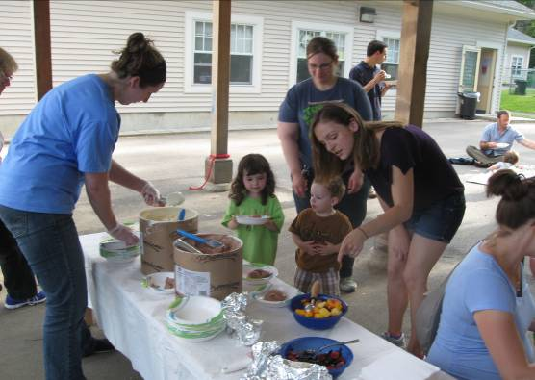

**Reasons to Celebrate**

**Connect with Bright Horizons**



Local Concerts

The Gorse Children’s Center is sponsoring the **Children‘s Concert Series**

at Buttery Brook Park this summer!

The concerts are held during the day from 10:00-11:00 a.m., so if your child is enrolled part-time or if you are taking a “stay-cation”, you may be able to enjoy these concerts:

*Wednesday, July 16: John Porcino*

*Wednesday, July 23: Miss Leticia*

*Wednesday, July 30: Roger Tincknell*



Buttery Brook Park is located at

123 Willimansett Street (Rt. 33), South Hadley

Rain Date Location: South Hadley Town Hall

Infant 1

The Infants have been interested in building lately. We’ve been using all different sized blocks, stacking them and knocking them over. The babies get very excited when they participate in this activity. We’ve explored different textured blocks and some with different images on them.

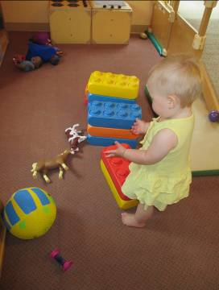

**Classroom Highlights**

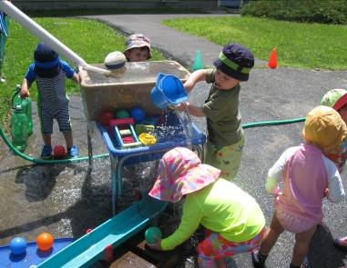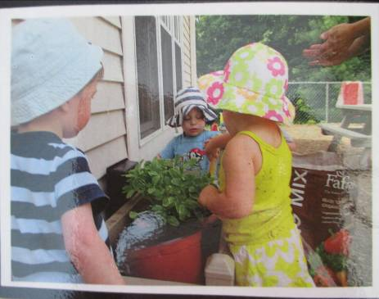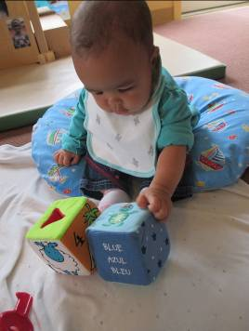

Toddler 1

Our investigation of plants continues! The plants have become so big that the children needed to repot them. The were so excited, stating that the plants are getting bigger because we are watering them. We also discussed how the sun and the soil help them grow. We’ve taken a few walks on campus to see all the different colors and types of plants and flowers that are growing.

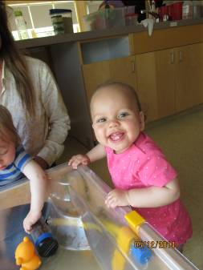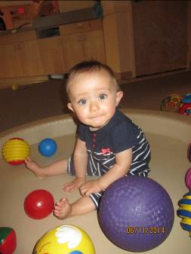

Infant 2

The babies in Infant 2 have been exploring water and other materials in the sensory table. Some of the babies enjoy splashing in the water, and others even clap their hand in the water. They have been exploring balls in the ball pit. They push and hit all the different textured balls. They seem to enjoy watching the movements of all the balls together in the ball pit.

Toddler 3

Toddler 3 has been playing in water! We’ve been observing and experimenting with the flow of water and balls through tubes and troughs, and testing floating and sinking objects in the water tables. The Dramatic Play area has been transformed into a picnic area with many diverse pretend foods to try. During our circles and play time, we’ve been telling stories together and using props to help us. Soon, we will even write a story with the older toddlers! The younger toddlers have been identifying body parts and practicing their ABC’s.

Preschool 1

Preschool 1 was busy this month in learning about birds--different types of birds, how they live, and what they eat.  Children were busy making a real life bird nest for themselves in dramatic play, making bird feeders using oranges and bird seed, and toilet paper rolls with sun butter and birdseed.  They learned about different kinds of birds like owls, ostriches, and flamingos.  We were also busy learning how an eco-system works. We made one bottle that had dirt, flower seeds, and crickets.  Another bottle underneath had water, snails, and fish.  The children loved watching how the condensation would go to the dirt level to water the plants and then go through the dirt to drip down into the fish tank so algae could grow to feed the animals.

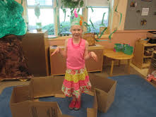

School Age

June is an exciting time for School Agers! As they are ending the school year and beginning their summer activities and vacations, we also have taken time this year to say “until next time” to three of our children. They have completed third grade and will be moving on to new adventures! We have truly enjoyed spending this time getting to know you all and hope the best for you in your new endeavors!

Meanwhile, we are gearing up to jump right into our School Age summer program, Camp Explorations! CAUTION!...EXTREME FUN AHEAD!

Rosemary’s Corner

As a young child, I went to the circus with my parents. I was quite excited! I watched the monkeys perform tricks and the lion jumping through the fire wheel. I had two rides on the elephant. She had a beautiful quilt on her back and a box to sit on with a place for my feet. I felt I could touch the sky! I asked for a third ride, but my parents said “No” because there were other children waiting in line. I got some cotton candy, and ate it after I went home. What a beautiful experience for me!

Happy Summer, Everyone! Rosemary

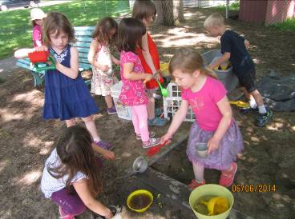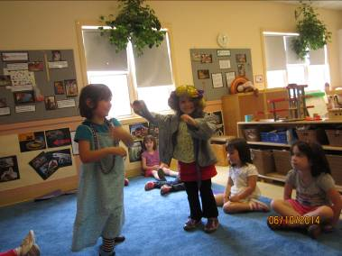

Preschool 2

June has been a busy month for Preschool 2. We have taken full advantage of the nice weather by spending lots of time outdoors. We have been doing our weekly yoga on the grassy hill playground. We went for walks on campus and have been exploring mud in the sandbox. The children have recently shown a lot of interest in storytelling. They’ll dictate a story to a teacher, then during circle they choose the character they want to be and assign parts for their peers. They have become so involved in performing, they’ve decided to make their own costumes. The children from Preschool 1 & 2 who will be going on to Kindergarten in the fall did an amazing job reciting the graduation poem during Step-Up Night!



**READY for SCHOOL Parent News--Executive Function: What Is It and How Can I Support Its Development in My Child?**

The term, executive function, is an educational buzz word that’s getting a lot of attention these days. Executive function has been compared to an air traffic controller in the brain. Through executive function, we manage the myriad complex tasks and challenges facing us daily. Executive function encompasses several skills, such as working memory, inhibitive control, and cognitive flexibility which are defined below.

Working memory refers to the ability to remember important facts or details, and call them up as needed. Through working memory, you remember to pay bills, take your child to a doctor’s appointment, or perform tasks at work.

Executive function skills are critical for later success in school and social settings. Teachers sometimes refer to executive function skills as “getting ready to learn” skills, because without these traits, children have difficulty focusing, prioritizing and persisting at a task. Early childhood is the ideal time to boost these skills. Below are a few suggestions for building executive function skills in the early years.

* Establish predictable routines and schedules. Use visuals or charts to help children understand your expectations. Spend time teaching children how to complete simple jobs, such as picking up toys, washing paint brushes, or setting the table at lunch. Learning to follow through and complete tasks helps boost working memory and inhibitive control.
* Play games, such as “Simple Simon,” or “Red Light, Green Light.” These games teach children to listen and follow directions.
* Offer open-ended toys, such as wooden blocks, to build problem-solving and cognitive flexibility. How many ways can you make a tower?
* Encourage dramatic play activities, such as playing house or playing store. This type of open-ended play boosts problem-solving, language development, and focus. Scaffold play initially for young children by assigning roles or offering props. Say, “I’ll be the waiter and you can be the cook. Let’s pretend that we’re making spaghetti.” As children mature, their play becomes more independent, as well as more abstract. Children may assign roles or extend the play over several days. They may also use objects symbolically. For example, a child might use a block to represent a camera.

Resources:

Center on the Developing Child at Harvard University (2011). *Building the Brain’s “Air Traffic Control” System: How Early Experiences Shape the Development of Executive Function: Working Paper No. 11.* Retrieved from [www.developingchild.harvard.edu](http://www.developingchild.harvard.edu)

Galinsky, E. (2010) *Mind in the Making*; William Morrow Publishing



**READY for SCHOOL News**

Inhibitive control allows you to make reasonable, measured choices, rather than responding to every whim or desire. You also learn persistence and focus. You clean the house when you’d rather watch television. Inhibitive control allows you to forge strong social relationships. You learn when to “bite your tongue,” and when to be honest.

Brain flexibility refers to the ability to change course, admit a mistake, or see another’s perspective. Flexible thinking is a necessary skill for any interactive relationship, including school projects, team sports, or assignments at work.

**Family Matters Series Webinar**

**Bright Horizons®** partnered with Ellen Galinsky, author of the highly acclaimed bestselling book *Mind in the Making* (Harper Collins 2010), to bring families a parenting webinar about executive skill development in young children.

You can watch the recorded webinar at [www.brighthorizons.com/execwebinar](http://www.brighthorizons.com/execwebinar).

**Seize the Summer: Fitness for Busy Families**

*Presented in collaboration with PHA*

Wednesday, July 23, 3:00 pm est



***Parents* *Magazine* Spotlights Bright Horizons Expert**

Bright Horizons was referenced in an article from the July 2014 edition of *Parents Magazine*. In the article, Potty Pressure, Linda Whitehead, Ph.D., vice president of education and development, offers thoughtful tips and advice about how to get your little one on track when it comes to potty prep. Linda advises that although the path to potty training varies from child to child,  a little support from parents, teachers –and even from the other students—can go a long way.

Read the full article at <http://www.brighthorizons.com/pottypressure>.

A separate *Parents Magazine* article features feedback from Dr. Linda Whitehead, where she discusses the benefits of family-style dining. A large part of the Bright Horizons curriculum, family-style dining not only helps children develop healthy eating habits, but also enables children and teachers to enjoy a meal together in a calm, respectful atmosphere. According to Linda, family-style dining also boosts self-confidence, teaches children mathematical concepts and builds fine motor skills.

Read the full article at <http://www.brighthorizons.com/mealstyles>.

**SAVE THE DATE: July installment of the Family Matters Webinar Series!**

Keep checking [www.brighthorizons.com/webinar](http://www.brighthorizons.com/webinar) for the latest information as it becomes available!

**Bright Horizons News**

