MONDAY | TUESDAY | WEDNESDAY | THURSDAY | FRIDAY
1
Pineapple Chunks

Pita Bread and Hummus
4  Closed for Holiday | 5  Cottage Cheese  Mandarin Oranges  Zucchini Bread | 6  English Muffin with jelly  Raspberry Yogurt | 7  Peaches  Breadsticks with Milano Sauce | 8  Mini Blueberry Muffin  Cubed Cheddar Cheese  Assorted Crackers
11  Vanilla Yogurt  Mixed Berries  Pita Bread with Hummus | 12  Mini Blueberry Muffins  Carrot Sticks  Ranch Dressing | 13  Pears  Cubed Cheese and Crackers | 14  Mini bagels with butter  Apple Slices | 15  Chunky Mixed Fruit  Banana Chocolate Chip Bread
18  Orange Blossom Muffin  Applesauce  Red & Yellow Pepper Strips  Ranch Dressing | 19  Vanilla Yogurt  Cantaloupe Chunks  Pita Bread with hummus | 20  Raisin Bread with butter  Orange Wedges | 21  String Cheese  Apple Slices  Tortilla Chips and Salsa | 22  Bananas  Cubed Cheese and Crackers
25  Mini Bagels with butter  Applesauce | 26  Corn Muffins  String Cheese and crackers | 27  Cantaloupe  Carrot Sticks and Ranch Dressing | 28  Vanilla Yogurt  Graham Crackers  Honeydew | 29  Pineapple Chunks  Pita Bread and Hummus
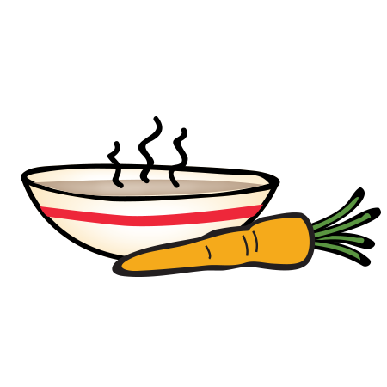
September 2017

