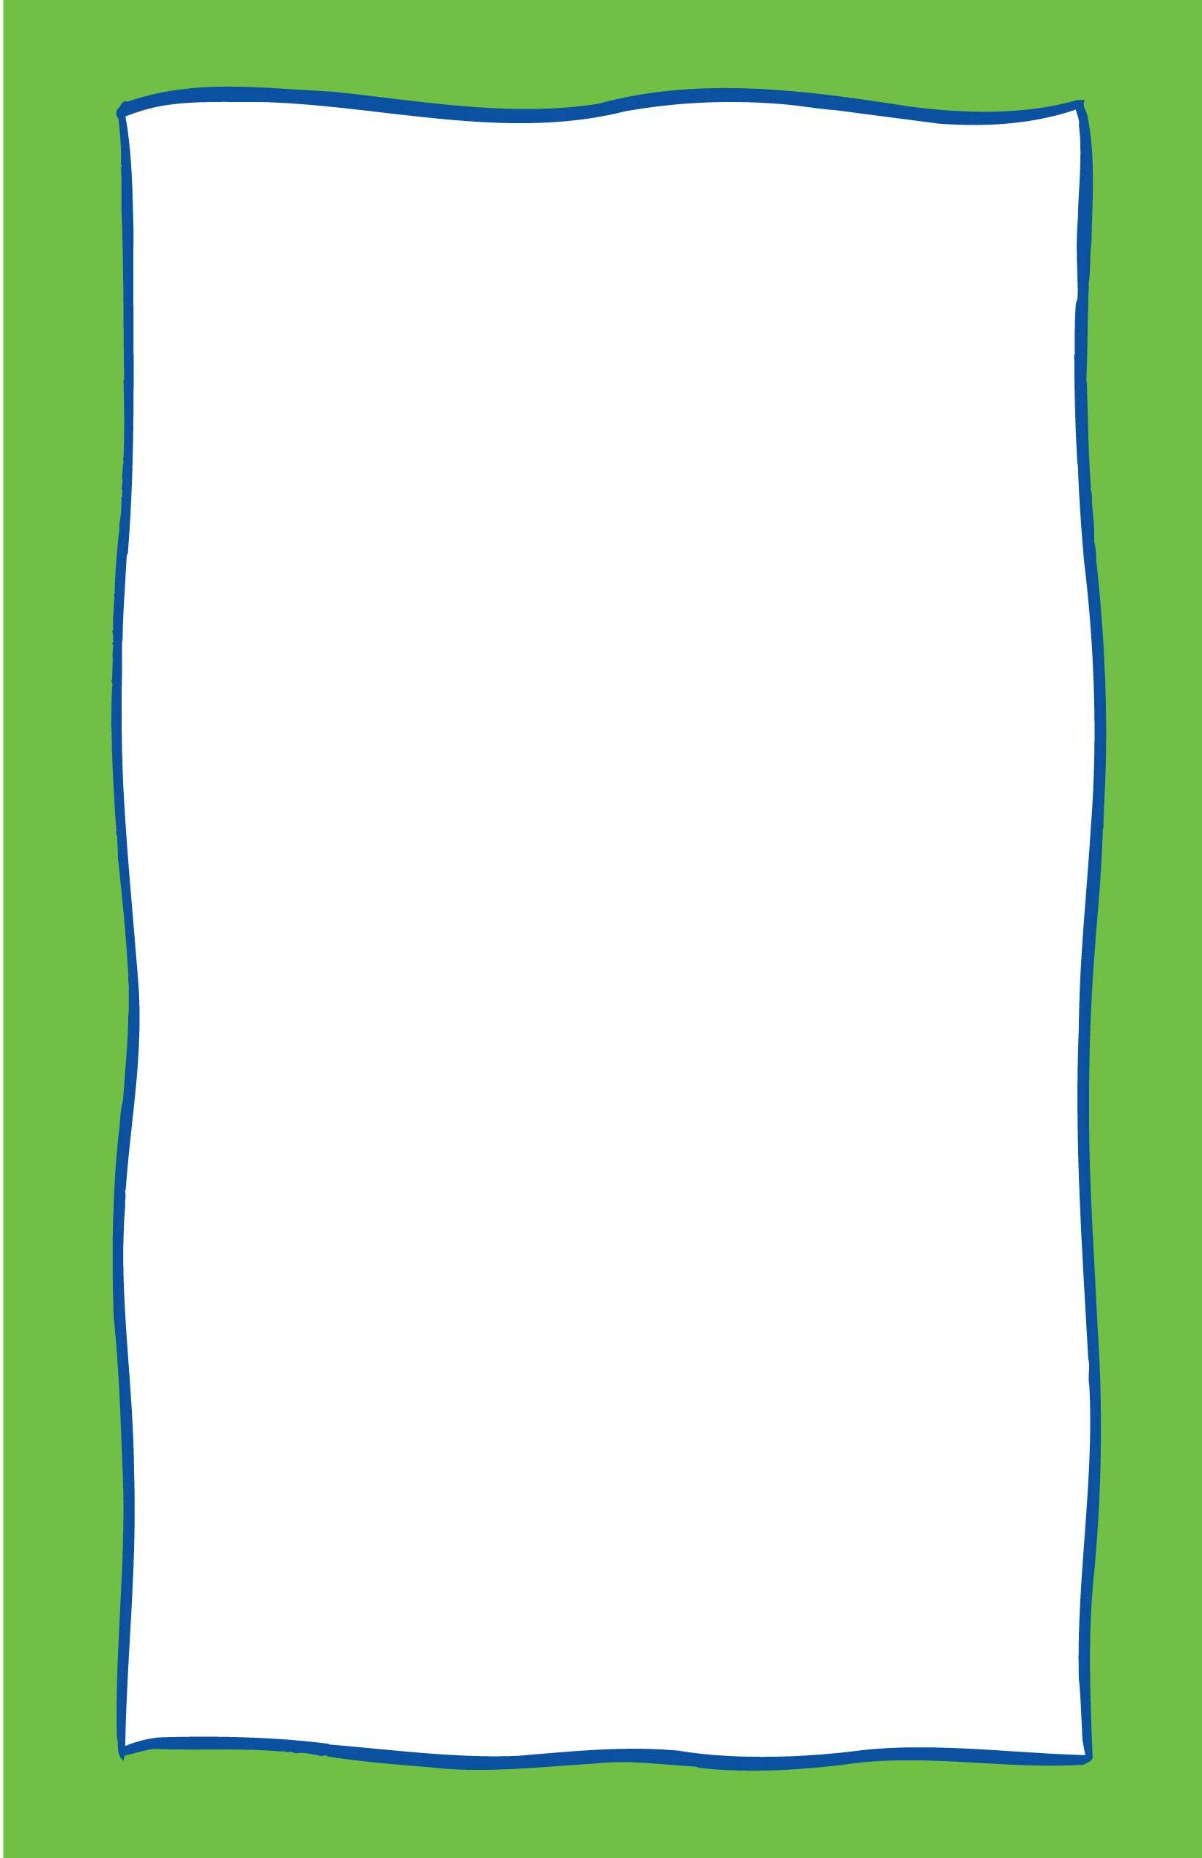
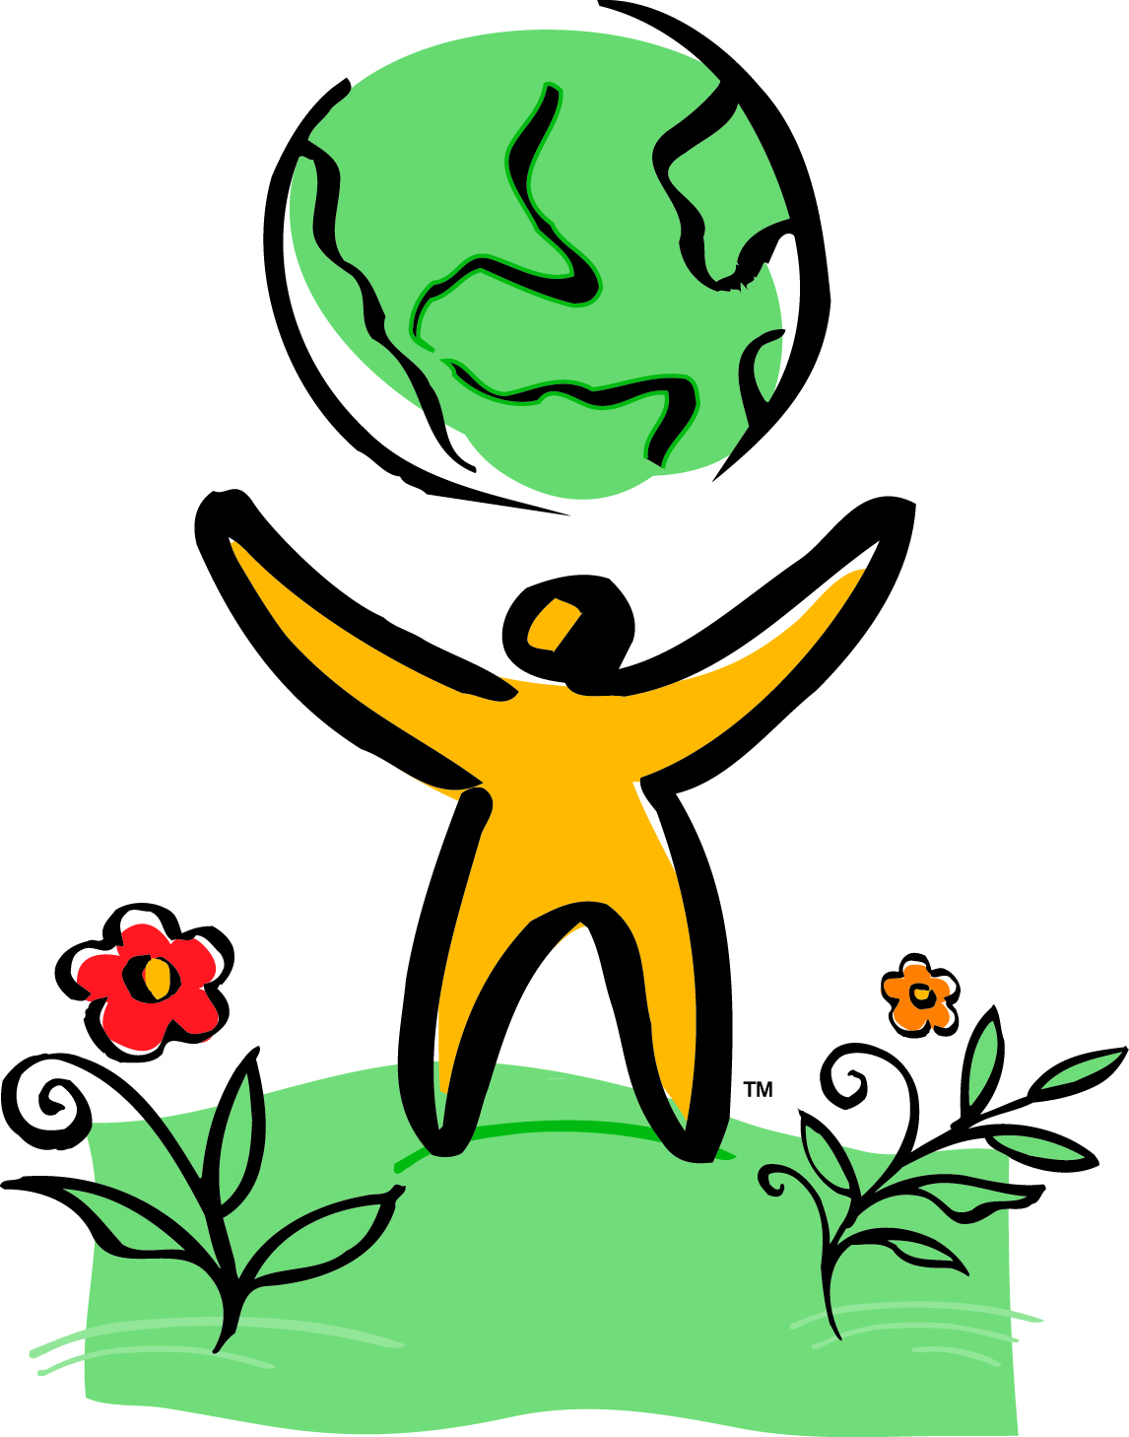
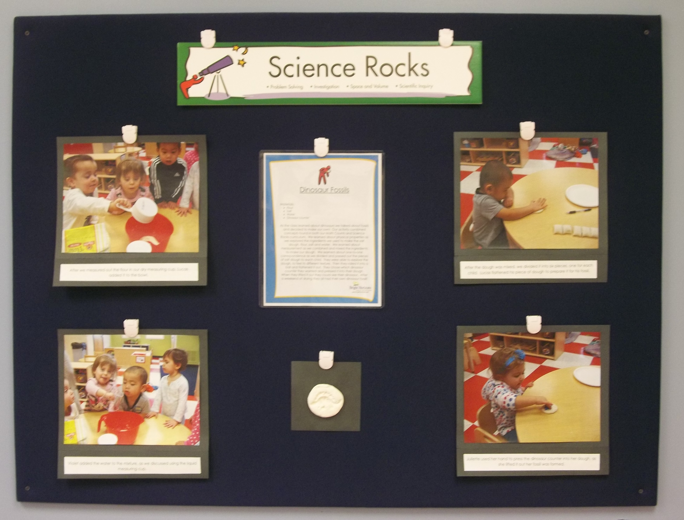

Did you know that at Bright Horizons at Spotswood…
- We document to make learning visible?
- We document to communicate to our families about children’s learning experiences?
- We document to help teachers reflect on children’s learning and to plan next steps?
- We document to help children reflect on their own learning experiences?
- Each classroom has a parent board that provides information about your child’s classroom including lesson plans, “What in the World Happened” documentation, schedules, menus and monthly calendars?
- Our documentation boards are unique because of our age specific classrooms and our emergent curriculum?
- A lot of thought and time goes into each and every documentation panel? Take a look at the many components that go into each panel:

- Don’t forget to check out documentation panels in our Movement Matters Zone, Outside, Cooking Club and Art Studio!

According to renowned educator Lella Gandini, documentation has the following functions:
- To make parents aware of their children’s experiences and maintain parental involvement
- To allow teachers to understand children better and to evaluate the teachers’ own work
- To make children aware that their effort is valued
- To create an archive that traces the history of the school and of the pleasure and process of learning by many children and their teachers

Did You Know?
Documentation Panels at
Bright Horizons at Spotswood
Teachers highlight different components of The World At Their Fingertips.
Pictures of the activity include captions and quotes to capture your child’s thoughts.
A detailed description guides you through the purpose of the activity and includes which age appropriate skills are highlighted.
We also include a sample of the project. Remember, we focus on the process and not the product! Check out the detailed description for more information!
Ms. Charnell’s Toddler Program
Dinosaur Fossils

